**VEER NARMAD SOUTH GUJARAT UNIVERSITY**

**SURAT**

J. P. DAWAR INSTITUTE OF INFORMATION

SCIENCE & TECHNOLOGY

M.Sc. (Information Communication Technology)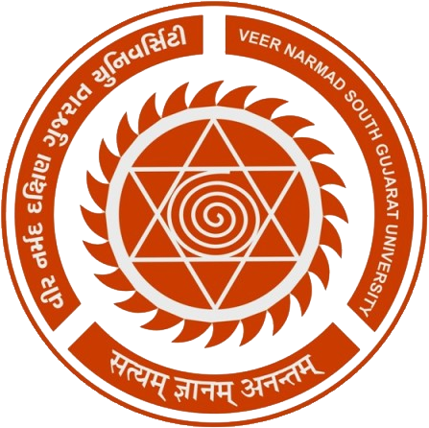

**3rd** Semester

M.Sc. (Information Communication Technology)

Year 20**19**-20**20**

PROJECT REPORT

ON

**“Online Education System”**

**GUIDED BY:** **SUBMITTED BY:**

Ms. Krishna Desai Sonar Tushar B.(10046)

**Prakshal IT Infotech**

Gulab Baba Mill Compound, Near Railway Station, Lal Darwaja, Surat - 395003